Trademark Classification
Introduction:
In today's fast-paced digital world, trademark protection is crucial for businesses to safeguard their brand identity. Accurately classifying trademarks into the appropriate classes based on the goods and services they represent is a vital step in the trademark registration process. However, with the vast array of goods and services available, this classification process can be complex and time-consuming. To address this challenge, this AI engineering task aims to develop an advanced AI model that can predict trademark classes with high accuracy based on user-entered descriptions of goods and services.
Objective:
- To create a model that classify the trademarks.
- Then save the model in wandb website.
- Then create a streamlit API for the predictions.
Procedure:
Model training:
In this model, I have used Bert model. It is a transformer-based model used for text classification. The process as follows:
- Load and preprocess the data.
- Implement a custom training loop in PyTorch, handling forward passes, loss computation, backward propagation, and optimization steps.
- Use cross-entropy loss for classification and a suitable optimizer (e.g., AdamW).
- Log training metrics like loss, accuracy, and validation performance.

Model Logging:
Track training/validation loss, accuracy, precision, recall, F1-score, and other relevant metrics. Log hyperparameters and model checkpoints.
API:
Use Streamlit to develop the API.
The app loads a pre-trained BERT model, specifically fine-tuned for sequence classification, along with its corresponding tokenizer. The model's parameters are loaded from a file named "model.pth", and it is set to evaluation mode to ensure that no gradients are computed during inference. The classification labels (corresponding to the 49 classes) are loaded from a numpy file, "label_classes.npy", which contains the possible output classes. The clean_text function is defined to preprocess the user's input by converting it to lowercase and removing any non-alphanumeric characters. This step ensures that the input text is in a standardized format before being tokenized. Streamlit's text_input widget captures the user's text input, which is then cleaned and tokenized using the BERT tokenizer. The tokenized input is padded and truncated to fit the model's input size requirements. The tokenized input is passed through the BERT model, and the logits (raw model outputs) are obtained. The class with the highest logit value is selected as the predicted class. The app decodes the predicted class ID into its corresponding label (from label_classes) and displays the result on the screen, allowing the user to see the classification outcome for their input text.
Result:
Model metrics:
Training accuracy: 0.8872
Training loss: 0.4340
Test accuracy: 0.8862
Test loss: 0.4330
Streamlit API:
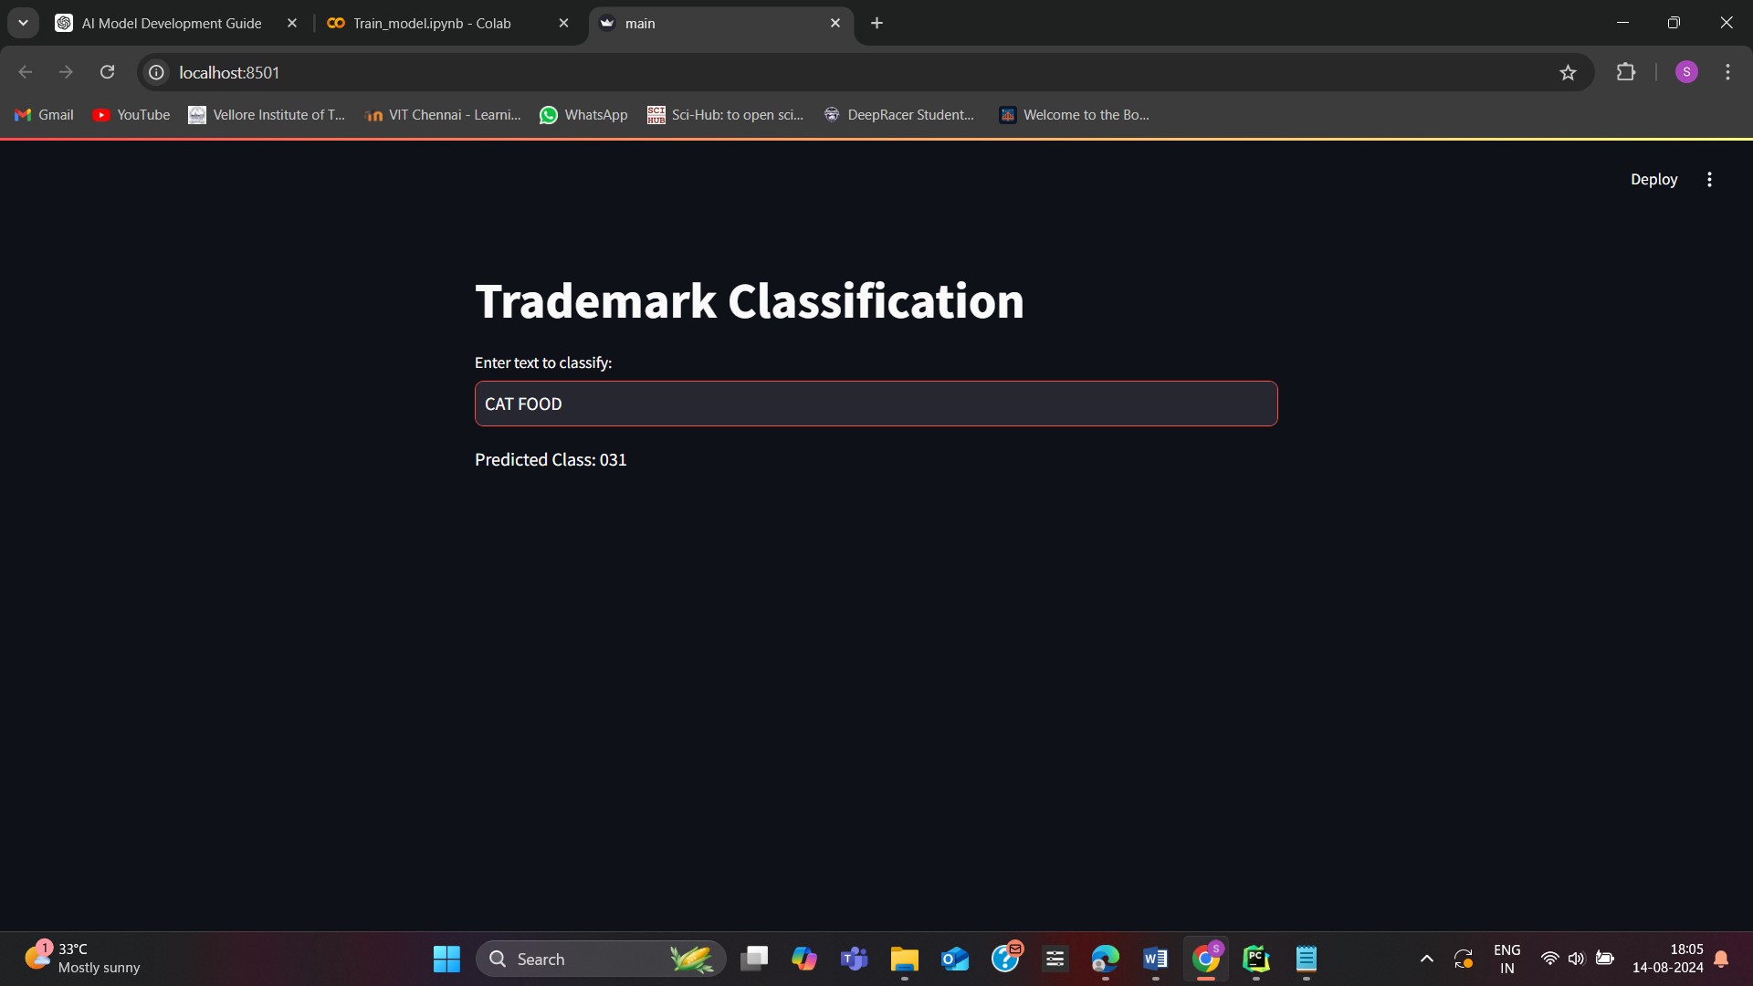
Conclusion:
This AI engineering task demonstrates the practical application of artificial intelligence in streamlining the trademark classification process, a critical function for protecting intellectual property. By developing an AI model trained on the USPTO ID Manual, creating a Streamlit API for real-time predictions, and implementing robust logging and monitoring practices, we ensure that the solution is both accurate and user-friendly. The additional integration of user management and request tracking adds a layer of efficiency and security, making the application well-suited for real-world deployment. This project not only enhances the automation of trademark classification but also exemplifies the importance of combining AI with good engineering practices to create reliable and interactive software solutions.

